Project report

ISYS20182 – Practical Project Management & Professional Development

Aidyn Temirkhanov (T0296159)

Mason Ireland (N0935168)

Sam Dutron (N0935596)

Abdulrahman Mohammad (T0280702)

Yat Wong (T0157434)

Table of Contents

1. Introduction 2

2. Survey of Existing Solutions 3

2.1 Yorkshire Festival of Story website 4

2.2 Derby Book Festival Website 5

2.3 Demand for the product 6

2.4 Company information 6

2.5 Software required 6

3. New Ideas 6

4. Design and Development 7

5. Evaluation of Product 16

6. Discussion/Conclusion 20

7. Professional issues 21

7.1 Professional 21

7.2 Ethical 21

Appendices 22

Appendix 1 – Used software tools 22

Appendix 2 – Meeting minutes 23

References 26

# 1. Introduction

A project Year of Stories with Read on Nottingham focuses on improving vital communication skills and has the vision to help families and young children to improve their life by giving support in aspects of communication skills. The Read on Nottingham is a program supported by Nottingham City Council and the Small Steps Big Changes organisation. Also, this project is funded by the National Lottery Community Fund.

The aim of the project help children develop reading, writing, speaking, and listening skills. Creating new events and activities for young people will help them find new friends, communicate with each other, and find like-minded people.

The main goal our team would like to achieve is to provide maximum support to the younger generation, do our best to help them improve vital language skills and help support families and schools through our program. The Nottingham Year of Stories 2023 project aims to support young children, families, and schools to help them get the early literacy skills they need.

One of our aims in this project is to make the website easily navigated by all audiences (families, children, teachers, professionals, and potential donors). Also, in our plans make the website with a variety of functions including:

* A calendar section for bookable and non-bookable activities. For instance, story trails, book signings, theatre, creative writing etc.
* An area where people their stories and storytelling videos, blogs, experiences and so on.
* Useful information on other literacy-related activities in the city.
* Area for financial donators, supporters, and project partners.

Figure 1 – Nottingham Literacy Trust website (Read on Nottingham page)

# 2. Survey of Existing Solutions

To allow us to evaluate the effectiveness of similar projects, we undertook background research to determine the strengths and weaknesses of the websites that were created.

## 2.1 Yorkshire Festival of Story website

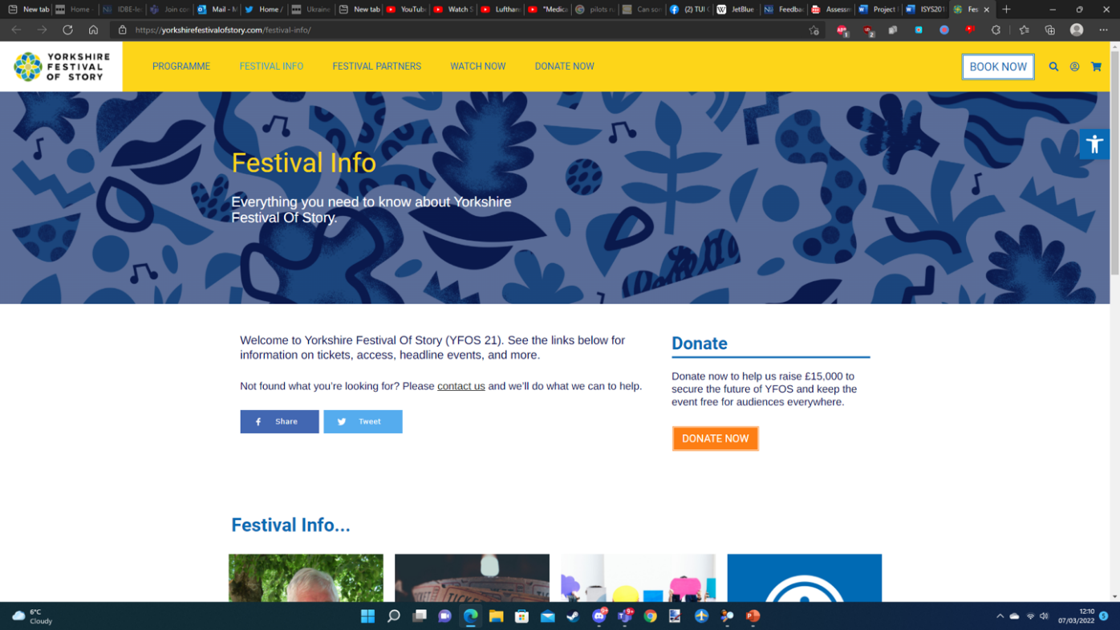

Figure 2 – Yorkshire Festival of Story website

The Yorkshire Festival of Story Website was designed for a similar purpose that is intended for the Read on Nottingham website as its purpose is to showcase an event and inform the public how they can get involved.

Advantages of Design

The design of the Yorkshire Festival of story website is colourful. This makes the site eye-catching to the user, which may make them want to browse the site more. The site has a clear organised layout, with a navigation bar at the top, information about the site with links and an organised footer with social media links and other information. There is an opportunity to donate on the website, allowing donations of £15, and £25, with a custom donation, amounts also available. The user can create an account and log in.

The website shows a lot of information about the Yorkshire festival of story, giving the user a clear idea of what the festival is about. There is a “Book Now” button which would usually allow the user to book events. This button is not working properly on the festival of stories site. There is a Facebook and Twitter page for the site which can be visited to check the festival activities, the user can also contact them for support with anything they need. There is a mailing list sign up for the user to be sent more information about the festival.

Disadvantages of Design

Although colourful, the design does not feel cohesive overall in terms of colour. No clear theme that people will associate with the brand. A specific colour scheme would make the site more memorable and more cohesive.

The “Book Now” button directs the user to a page with no information. The site could include more social media sites such as Telegram or Snapchat so that they can be contacted in more ways.

## 2.2 Derby Book Festival Website

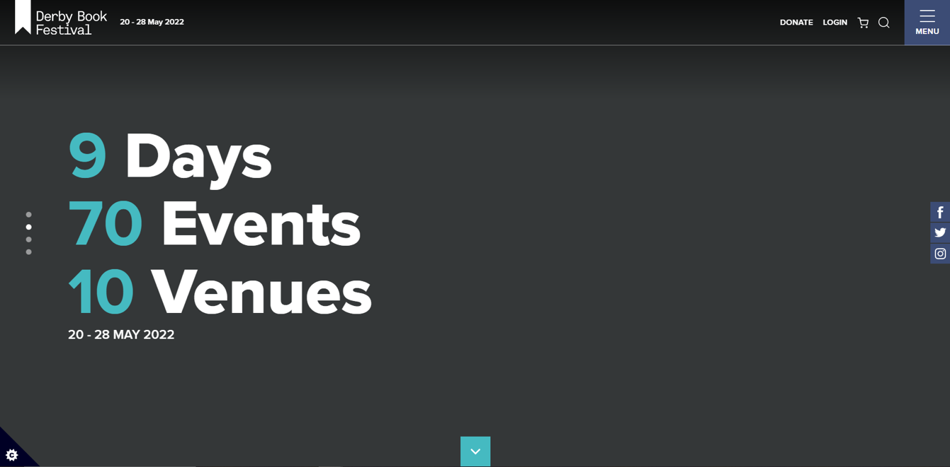

Figure 3 – Derby Book Festival Website

Advantages of Design

The overall colour palette and design feel cohesive. The site is professionally organised and responsive. It includes a slideshow and multiple links for more information on the home page. Also, it Includes small social media links anchored to the right side of the page. Uses a drop-down button which includes information and a lot of links to other pages on the site.

Disadvantages of Design

The overall appearance of the Derby Book Festival Website is designed well but to improve the website our group would like to improve the website by using some features which are not on the website. For instance, use brighter colours that will impact the user and at the same time avoid using a lot of colours to not distract the user.

## 2.3 Demand for the product

Books are an integral part of our lives and the demand for books is increasing day by day. Every year, millions of books are published in different genres and for different ages.

One of the popular categories of books is children's books. Especially storytelling stories with different characters to captivate children.

Following this demand, the Read on Nottingham organisation decided to create the Year of Stories 2023 website to support families and children with reading, writing, and speaking skills.

## 2.4 Company information

The Read on Nottingham is an organization that provides vital language support and works with families and the young generation to improve their life chances by giving early literacy support. As well as focusing on the early years, the Read on Nottingham organization provides support to the children from primary to secondary school.

The main aim of the project is to provide support to children and their parents and create a sustainable community of readers and storytelling. Also, the Year of Stories will allow organisations to understand who else is working in the City to improve literacy and support partnership building, engage the whole City in realising the vision for literacy, highlighting progress, celebrating success and identifying the gaps, align the activities of the organisations to reach a wider audience and create long term ownership and integration of literacy into our lives, which will ultimately improve the below national average literacy levels in the City.

## 2.5 Software required

To create the Year of Stories website the group decided to use front-end development programming languages such as HTML, CSS, JavaScript and to create a backend development and provide access to the database the group used PHP programming language. Also, to store the organization information and event details the phpMyAdmin open-source administration tool was used. Additionally, to ensure every group member can access the database our group leaders decided to use the XAMPP web server solution stack package to ensure every group member is able to access information in the database.

# 3. New Ideas

Based on researched information from various sources and after discussion with the organization members, our team decided to add new features to the Year of Stories website.

The group decided to use a database management system to illustrate information about the events and information about the organization and partners. Also, our group decided to include searching events parts to help the user find the right information without wasting the amount of time. Another feature the group has created is the user and admin panel parts. In these parts, the organization's IT (Information Technology) department members can update the existing event, change the time, add a new event, or remove it from the user panel. Also, in the admin panel, the IT department members can update partners' details, and change the images and partners' page details.

As mentioned in chapter 2, to implement these features the group used programming languages such as HTML, CSS, JavaScript, PHP, and SQL. To store all the organisation information the group decided to create a database table in a phpMyAdmin database system.

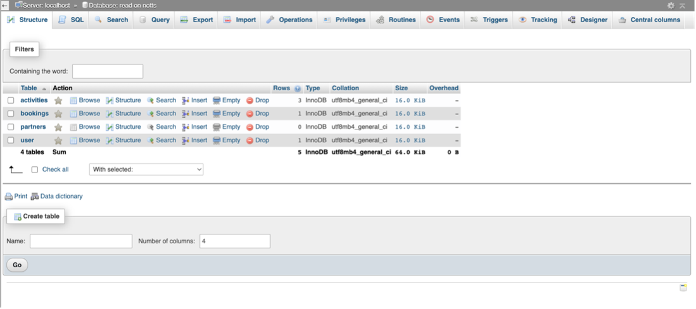

Figure 4 – PhpMyAdmin panel

# 4. Design and Development

Methodology

Before we started working on the design, we had to determine the project management methodology that would be followed. The Agile Development methodology was chosen for our project because Agile allowed us to have the ability to split our project into separate sprints where a specific part of the website could be designed, developed, and implemented one at a time. This approach was also very flexible from an overall project viewpoint as it allowed us to easily adapt to changing needs of the client and implement changes through future sprints. Furthermore, the use of this methodology assisted us in obtaining feedback as each sprint required us to create a specific part of the website with a certain degree of functionality. This progress could be shown to the client to allow them to identify potential improvements to ensure we would be able to deliver a high-quality resource. (Wrike, Unknown)

Interface Design

Upon choosing the methodology, the process was started of determining how the website would look beginning with the home page. To create our designs, we used Canva which is free to use collaboration graphical design platform.

Figure 5 - Initial Design of Home Page from Canva

Figure 5 shows the initial design that was created for the home page. The top and bottom of the page contained a header and footer which would be the only aspects of the website that would be consistent on all pages. The home page design also proposed a slideshow, introduction, and the boxes at the bottom of the page showed the location of links to other pages of the website allowing for faster navigation.

Figure 6 - Initial Design of Activities Page from Canva

Once the Home Page had been implemented, the activities page was designed. Figure 2 shows the proposed design with the use of a search bar that would allow users to easily find a specific activity. The images and activity description were to appear in a box allowing the user to clearly understand what each event is about. A consistent design including font sizes and background colours would be applied to aid the user in navigating the website with the aim of making it easy and enjoyable to use. This was especially important considering the target audience of the website would be younger children who would make it important for us to avoid designing a website that would be too complicated to use.

Figure 7 - Initial Design of the Explore Us Page from Canva

Figure 8 - Initial Design of the Partners Page from Canva

Figure 3 and Figure 4 show the initial designs of the ‘Explore Us’ and ‘Partners’ pages. The purpose of the explore page was to allow users to explore more information related to the Read-on Nottingham project. The user would be able to navigate through different articles each containing an image and description to provide the user with a context as well as a read more button to take the user to the location of the content. Meanwhile, the purpose was the partners' page was to show the logos of all the partners involved in the ‘Read on Nottingham’ project. Upon clicking on a Partner Logo, the user would be directed to the chosen partner's website. Also, the design of the partners' page contained the mission of the project as well a contact form to allow individuals to contact the event organisers directly.

Database Design

Figure 1 - Initial Design of the Databases through Lucidchart

Figure 5 shows the design of the tables that were utilised for the website database. The database was essential for allowing the creation of a dynamic website as it would allow website content such as events and further reading content to be stored. The diagrams of the designs were created using lucidchart and show the name of the table, column names, column and values and the declaration of primary keys.

The design consisted of six tables. Each table excluding the admin table contained an ID which served the purpose of the unique primary key. This was included as website admins would have the ability to modify content in each of these tables. In the statements performing the updates, the ID could be used in a where clause ensuring only a specified row was modified and deleted.

The purpose of the activities table was to store the activities that were being hosted as part of the event. It included several fields including the name of the event, the date the event would be hosted on as well as the number of spaces. This field was included to allow the event organisers to control attendance at popular activities. Furthermore, a short description intended to be displayed on the activities page was stored as well as a description for the event details page. Finally, the file name of an image to be displayed on the activities page was stored as well.

The booking table was designed to allow participant information to be stored in the database. This included information such as the event name, parent / guardian name, number of attendees and contact information to allow them to be informed of any changes that were made.

The explore content and partners table was designed to store content that would be displayed on the website. Each table contained a link when used in conjunction with an <a href> HTML element would redirect the user to another page based on the relevant content e.g. the home page of a partner.

Finally, the admin table was used to store the username and password that were required to be imputed to access the admin elements of the website. This table did not contain any primary keys because it only contained one value (username & password) that would be used by all admins.

Software Used

For the development stages, several a range of software was utilised for the creation of the website.

Firstly, Notepad++ was required to develop the code for the website. Its use was flexible because it was compatible with all of the programming languages we had to use which were HTML, CSS, PHP and JavaScript. Another reason why we chose to utilise Notepad++ was that it is free to use which ensured we did not occur any development costs. However, reflecting a drawback of using Notepad++ is that it did not contain a built-in syntax checker which could have accelerated the development process as less time would have been spent fixing issues with the code.

Also, Xampp was used which came included with MySQL allowing the use of PHPMyAdmin which allowed for the creation and management of the database and the tables located within. Xampp also contained the Apache webserver which was used to host all of our web pages. Having both of these functions integrated using the same software made it more convenient for the development team as they could access the website and database from one place which meant that less software had to be installed.

Programming Development

This section will cover the processes that were used to develop parts of our code and provide an overview of the problems that were faced and how they were solved.

One of the most advanced parts of the website was the implementation of a booking system which utilised PHP. The first step that was taken to develop the booking system was to define the goals that the program would be expected to achieve which are listed below.

* Take details from the booking page and insert them into the bookings database
* Retrieve the event name for the specified from the activities database so it can be inserted into the bookings database.
* Check that the number of attendees being added by the user is not more than the number of spaces on the activities page.
* If the number of attendees being added by the user was more than the number of spaces, prevent the booking from taking place and redirect the user to the add booking page

Once, the goals had been defined, the developers created pseudocode to help them plan out the layout of the code. Using pseudocode was also useful because as it was written in plain English, everyone would be able to understand the processes taken in each step.

Pseudocode

**Request the event ID from the booking page**

**SQL select all statement from the activities table where the ID equals the event ID**

**Run the SQL query and fetch the result**

**If the parent name variable has been posted**

**A new variable called parentName is set to the value posted from the booking form**

**If the number of attendees variable has been posted**

**New variable called noOfAttendees is set to the value posted from the booking form**

**SQL update statement amending the number of spaces to number of spaces -number of attendees in activities for the selected event**

**Run the SQL query**

**SQL select statement on a number of spaces in activities for the selected event**

**Run the SQL query and fetch the result**

**If the number of spaces row is lower than 0**

**SQL update statement on activities to amend number of spaces to number of spaces + number of attendees for the selected event to revert the changes**

**Run the SQL query**

**Redirect the user back to the booking page and stop the code**

**If an email address has been posted**

**New variable for email address which is set to the value posted from the booking form**

**If a phone number has been posted**

**New variable for a phone number which is set to the value posted on the booking form**

**SQL insert statement to insert the event name, parent name attendees contact number and email address into the booking table with the values set to the variable names**

**Run the SQL query**

**Redirect the user to the booking success page**

Actual Code

Figure 9 - Image of the actual code for addBooking.php

The actual code for the add booking program is shown above in Figure 9. The implemented code follows the same structure to the pseudocode however with some minor revisions. An issue that was experienced was that if the user attempted to enter a field that contained an apostrophe (‘), an SQL syntax error would be generated. After troubleshooting the issue, it was discovered that such inputs would had to be handled using the ‘str_replace’ function to add a hash before any occurrences of an apostrophe in the variables before the SQL statement was run.

Another important feature that was developed was the activities page which utilised a combination of HTML and CSS to display and style the content, and PHP to retrieve the activity data from the database. The activity page had the following objectives which are listed below.

* Display all activities that are stored in the event database
* Display basic information about the event such as a short description, the event name and the event date
* Allow the user to search activities based on the event name
* Allow the user to order the activities by A-Z and the date of the event
* Upon clicking on an event, redirect the user to the event details page for that specific event.

Pseudocode for displaying activities

**If value has been posted in the search bar**

**Declare a new variable for the search bar set to the declared value**

**SQL select statement retrieving all the activities that contain a name like a search bar value**

**Else if list order has been posted**

**Declare a new variable for list order set to the declared value**

**If the value equals date**

**SQL select statement to retrieve all activities in order of date**

**If value equals name**

**SQL select statement to retrieve all activities in order of name in ascending order**

**If value equals descending name**

**SQL select statement to retrieve all activities in order of name in descending order**

**If value equals the number of spaces**

**SQL select statement to retrieve all activities in order of number of spaces in descending order**

**Else**

**SQL select statement to retrieve all activities in order of date**

**Run the SQL query**

**While each result is fetched from the database**

**Echo div elements for styling the activities page content**

**Set background image to the image file name stored in the database**

**Set title to the event name row which is enclosed inside a link to the event details Page**

**Set the event description to the short description row in the database**

**Set the event date to the date row stored in the database**

**Close all of the div element tags**

Actual Code

Figure 10 - Image of the code to display events on activities.php

Figure 10 shows the actual code that was created on the activities.php page. Several issues were experienced working on this section. Firstly, the SQL statement for the search bar was initially unable to fetch any results on several occasions. It was discovered that the SQL like function was case sensitive preventing query results on appearing. To fix this issue, the statement was rewritten to convert name in the activities database to lower case as well as the search bar variable used for the like statement. Another issue that was experienced was styling the content correctly onto the page. This required the CSS to be tweaked until the development team was satisfied with the results. To ensure that the latest version of the CSS file was used, the cache had to be disabled so the most recent changes could be viewed.

# 5. Evaluation of Product

Requirements

Before creating the website, we agreed on initial requirements in our project proposal. These are listed below with an explanation of how they were met.

* Inform the user about the Nottingham year of stories

The website had to include a suitable amount of information about the year of stories, allowing users to understand the mission of the year of stories with ease. The home page of our site includes a summary of the Nottingham Year of Stories. The “Explore Us” section provides multiple sections where the user can read further about the year of stories, these can also be added, changed and deleted by the administrator without needing to access the website code. The “Our Partners” section informs the user about the Read on Nottingham partners, with links to each of their websites, a promotional video is also included on this page.

* Responsive design

The site had to be responsive so that it could be viewed on multiple devices. To do this, a “burger” menu was added to make the site more compact, this allows mobile users to tap on the menu when they want to see the navigation links to other pages. Each page changes responsively to screen size changes, such as users being on a mobile phone.

* Child Friendly Design – Bold Text, Easily Understandable language

We wanted to make the design of the website colourful and easy to understand so that all ages can view the website with ease. This is important because the year of stories aims to encourage reading in young people.

* The site must be visually appealing

User retention is important for a website and making it visually appealing can help to aid this. We wanted the site to be visually appealing, this is so that users are attracted to the site and want to explore more. We used a light green colour for the theme of the site, we tried to make the layout visually appealing, including colourful images.

* The site must be easy to navigate

As per the laws of web usability, the user should easily understand the site and how to use it, with each click being instinctive. The site must be easy to navigate so that users know exactly where they are and do not get lost. This decreases the chance of the user becoming frustrated and leaving the site. Our website has a clear, concise homepage with key information included. The navigation bar and the footer stay the same on each page, keeping the header in the same place allows the user to get back to the homepage when needed.

* The site must include a navigation bar

A simple navigation bar is important for a website as it allows the user to explore the site without complication. We included four pages on our navigation bar with clear indications of what would be on those pages.

* The site must include images

We wanted to include images on the site to make it more visually appealing, adding more for the user to look at.

* Calendar for Activities

The site had to include a calendar for activities so that the user could search through activities taking place. The activity calendar includes a search function, where users can search for individual events. The activities can also be ordered by Event Date and from A – Z, as well as the number of spaces left available for the event.

* Donation Section

This requirement was unable to be achieved due to time constraints.

Testing

|  |  |  |  |
| --- | --- | --- | --- |
| **Test Name** | **Test Description** | **Expected Result** | **Actual Result** |
| View Activities | Testing whether it’s possible to view activities on the activities page | All activities stored in the database are displayed with the relevant information | Success, all activities are displayed onto the page |
| View Explore Us Content | Testing whether it’s possible to view the explore us content on the explore us page | All content stored in the database should be displayed with the relevant information and links | Success, all content is displayed onto the page |
| View Partners | Testing whether it’s possible to view the project partners from the partners page | All partners stored in the database should be displayed with their name and logo | Success, all partners are displayed onto the page |
| Responsive Design | Testing whether the website can be used on devices with small screens | The website is responsive depending on the user’s screen size | Success, Partly successful, most content is responsive however some images appear stretched on smaller screens |
| Home page navigation buttons | Testing whether each navigation button works correctly | The user is taken to the correct page when clicking each button | Success, Home page navigation buttons open each page correctly in a new tab |
| Slideshow | Testing whether slideshow changes correctly with no issues | Slides change every few seconds with no image stretching or sizing issues | Success, Slides change every few seconds, no issues with image ratio or other unexpected changes |
| Social media links | Testing whether each social media button works correctly | Each social media button clicked takes the user to the corresponding social media site | Success, Each social media button clicked takes the user to the corresponding national literacy trust social media account |
| Admin Add Events | Testing whether events can be added successfully | Event added to the site and activities page updated | Success, Events are added on the site and updated on the events page |
| Admin Edit Events | Testing whether events can be changed and deleted successfully | Events can be edited and deleted by the admin | Success, Events are edited and deleted, successfully updated on the website |
| Admin Add Explore Content | Testing whether explore content can be added successfully | Event added to the site and activities page updated | Success, Explore content is added, successfully updated on the explore page |
| Admin Edit Explore Content | Testing whether explore content can be changed and deleted successfully | Explore content can be edited and deleted | Success, Explore content is edited and deleted, successfully updated on the website |
| Admin Add Partners | Testing whether partners can be added successfully | Partner added to the site and activities page updated | Success, Partner is added, successfully updated on the partners page |
| Admin Edit Partners | Testing whether partners content can be changed and deleted successfully | Partners content can be edited and deleted | Success, Partner is edited and deleted, successfully updated on the website |
| Admin View Bookings | Testing whether bookings can be viewed successfully | Bookings can be viewed by the admin, including number of attendees | Success, Bookings successfully appear, showing relevant information to the booking |
| Admin Edit Bookings | Testing whether bookings can be changed and cancelled successfully | Admin can edit individual bookings, as well as being able to cancel | Success, Admin can successfully change booking information, also able to cancel the booking |
| Search Events | Testing whether event names can be searched. | Correct search appears with no errors. | Success, Correct events appear when searched. |
| Order By Event Date | Testing information on the Activities page and ordering events by event date. | Information on the Activities page is sorted by event date. | Success, Events sorted by event date. |
| Order By A - Z | Testing information on the Activities page and sorting in ascending alphabetical order. | Information on the Activities page is sorted in ascending alphabetical order. | Success, Events sorted in ascending order. |
| Order By Z - A | Testing information on the Activities page and sorting in descending alphabetical order. | Information on the Activities page is sorted in descending alphabetical order. | Success, Events sorted in descending order. |
| Order By Number of Spaces | Testing information on the Activities page and sorting by number of spaces. | Information on the Activities page is sorted by number of spaces. | Success, Events ordered by number of spaces. |
| Change order button | Testing whether the change order button can order events by selected categories. | The change order button applies the selected changes and displays them. | Success. The change order button applies the selected changes and displays the information in the selected way. |
| Link to the video on the Partners page | Testing video playback when the user clicks the play button. | Video is playing with the sound when the user clicks the play button. | Success, when the user clicks the play button, the video is playing. |

# 6. Discussion/Conclusion

The Year of Stories website as noted before in this report gives information about the Nottingham Year of Stories 2023, as well as there is a searching bar on the website to let the user search on a specific event and the user can order the search result either by alphabetic order, event date or a number of spaces available. This is an extremely user-friendly website that provides users of all ages with information about Nottingham events easily.

As a result of this endeavour, the team learned a lot and made significant progress. One of the most important concepts emphasised was the need of having a decent graphical user interface, and this project demonstrated how important it is to make a product appear professional, elegant, and appealing. We employed a variety of computer languages to do this, including PHP for backend development and HTML, CSS, and JavaScript for frontend development.

The group's ability to work successfully together was largely due to the well-organized group meetings that were held regularly to keep track of the website's progress. This made it easy for the team to work together because everyone was kept up to date on the website's progress. The group used social networking platforms like Microsoft Teams to connect. This allowed the group to communicate with one another at any time of day or night; this is one of the key reasons the group got along so well, as continual contact is required to complete a good project.

Our group has learnt how to create a website with this quality by working as a group and understanding how to work as a team. The group leader was also responsible for distributing the tasks between the group members

The website might be enhanced and improved further by creating a form to allow the users to register by their emails and receive all the news about the events recently and this might be taken into concern if we got more time.

Overall, the team performed admirably, working closely together, and putting in long hours to maintain a high level of work. More features may have been added to improve the website with more time.

# 7. Professional issues

In order for the public to have confidence in this website, the team members considered different aspects of legal, Privacy, and social issues before creating the website. Privacy is, by far, one of the most controversial issues in computer ethics. On one side of the argument, users do not want information that can be easily obtained from available technology to be accessible to the server or website being accessed. At the same time, such information is invaluable to law enforcement when tracking down criminals operating over the Internet. Team members follow the Computer Society Code of Ethics and Professional Conduct (BCS) during operations to minimize the chances of risk.

# 7.1 Professional

First of all, human privacy includes traditional personal privacy and modern personal data. Traditional personal privacy has a name, date of birth, ID number, marriage and family, education, etc. Modern personal data are user name and password, IP address, etc. Reasonable and legitimate privacy should be protected. On the Internet, privacy is extremely vulnerable, and the most direct effect of this is that the personal rights of citizens are violated. In the public interest, personal information is collected and stored by the BCS Code of Ethics and Professional Conduct (BCS) 1.6 Respect for Privacy: "Computing professionals should only use personal information for legitimate ends and without violating the rights of individuals and groups." Users will sign in to ensure their privacy is protected before personal data is collected.

# 7.2 Ethical

As panelists consider ethical issues, The panelists agreed on the importance of safeguarding the rights of third parties, and there are many different organizations and teams of third parties in The Nottingham Year of Stories 2023 project in the Computer Society Code of Ethics and Professional Conduct (BCS) 1.7 Honor confidentiality." Computing professionals should protect confidentiality except in cases where it is evidence of the violation of law, of organizational regulations, or of the Code.". Many users of The Nottingham Year of Stories 2023 project did not want the site to collect data on individuals' participation in events, and the panelists' solution was that the site would not collect redundant data.

# Appendices

# Appendix 1 – Used software tools

To communicate with group members, we have used Trello to divide the tasks, show the deadlines for each task, and move the task to the folder called “Done” if the task is completed.

Figure 10 – Trello dashboard

Also, the group used a GitHub. A GitHub is a platform to let the users share their code and see the changes. The group leader created a repository and other group members branch it.

Figure 11 – GitHub dashboard

To have a call between the group members and inform the next meeting the group used a Microsoft Teams software application. We scheduled a meeting weekly and last few weeks twice a week to track our progress and exchange ideas.

Figure 12 – Microsoft Teams chat window

# Appendix 2 – Meeting minutes

**Meeting 1**

Date – 22.02.2022

Attendance – Mason, Aidyn, Sam, Yat, Abdul

Overview – This was the group's first meeting. In this meeting, the group discussed the software tools such as Trello, Visual Studio Code, and Notepad. Also, in this session, a group discussed the GitHub account. After discussing software tools, the group nominate a project manager who contacts the clients and clarifies some design parts. All the ideas from the meeting have been sent to the Teams group.

Duration – 20 minutes

**Meeting 2**

Date – 04.03.2022

Attendance – Aidyn, Mason, Sam, Yat, Abdul

Overview – In this session, a group discussed the existing websites with a similar topic. Also, the basic structure of the website was created with the Home, Activity, Explore more, Partners pages. Also, in this session group created a basic design of the Home Page using a website for the design called Canva.

Duration – 38 minutes

**Meeting 3**

Date – 11.03.2022

Attendance – Mason, Aidyn, Sam, Yat, Abdul

Overview – In this meeting, the group created HTML and CSS project files for the home page to work further. Mason decided to work on the slideshow part. Aidyn decided to create div boxes at the bottom of the page. Yat has decided to work on the description and improve the navbar i.e., changing the font. Sam and Abdul were focusing on the report part. Especially, the survey of existing solutions part illustrates information about another website with a similar topic.

Duration – 11 minutes

**Meeting 4**

Date – 28.03.2022

Attendance – Aidyn, Mason, Sam, Yat.

Overview – Before the session, the home page was created with slideshow, navbar and navigation buttons. Also, the project leader divide tasks among each group member.

Tasks are given out:

* Sam and Abdulrahman – working on the report part. Design section.
* Yat – Make changes to the intro and move this section about the buttons and remove the images.
* Aidyn – Look into making changes to the header and try to improve the home page.
* Mason – Work on the activities page

Duration – 26 minutes

**Meeting 5**

Date – 1.04.2022

Attendance – Aidyn, Mason, Sam, Yat, Abdul

Overview – In this meeting, we were discussing the tasks that were divided in the last session. Also in this session, we have discussed the website data and what software tool to use to store the data. The group leader set the tasks for the group members. Sam, Yat, and Abdulrahman will focus on the design of the explore us and partners’ page. Yat, Mason, and Aidyn will focus more on the tasks divided from the previous session

Duration – 18 minutes

**Meeting 6**

Date – 06.04.2022

Attendance – Aidyn, Mason, Yat, Abdul

Overview – In this session has been decided to get all the pages developed at a decent level by the end of next week so the group will be able to focus on fixing things and potentially adding new features.

Duration – 17 minutes

**Meeting 7**

Date – 09.04.2022

Attendance – Aidyn, Mason, Sam

Overview – In this meeting, a group discussed the explore us page. Especially about the font and text part. Also, the home page was developed, and Yat added an introduction to the home page.

Duration – 17 minutes

**Meeting 8**

Date – 11.04.2022

Attendance – Aidyn, Mason, Sam, Yat, Abdul

Overview – Aidyn demonstrated the completed design of the partners and “explore Us” page. Also, in this session, a group started preparing for the presentation part with the clients. Aidyn and Sam create ppt document that added information about the Year of Stories website. Mason was trying to improve the admin panel part so the admin will be able to change event details such as date/time, title, description, available spaces and add the information about organisation partners and change the images.

Duration – 20 minutes

**Meeting 9**

Date – 26.04.2022

Attendance – Aidyn, Mason, Sam, Abdul

Overview – Before the meeting, we completed the project website part. During the meeting, the group members were discussing the meeting with the clients. The group was focused on the presentation part. Sam decided to take an introduction part about the website. Aidyn decided to discuss the home and explore our pages. Mason decided to explain more about the back-end side of the website and demonstrate the admin and user panel. Abdulrahman decided to focus more on the partners' page.

Duration – 20 minutes.

**Meeting with the clients from Read on Nottingham**

Date – 27.04.2022

Attendance – Aidyn, Mason, Sam, Abdul

Overview – In the meeting with the clients, the group explain the aim of the project, implemented features, demonstrated the website, and answer the question from the clients.

Duration – 30 minutes.

**Meeting 10**

Date – 1.05.2022

Attendance – Aidyn, Mason, Sam, Abdul, Yat

Overview – The group is already completed the project part of this assignment and had a presentation with the clients. In this session, the group members decided to focus more on the report part and divided parts. Also, Mason decided to record a demonstration video about the Year of Stories website. Other group members have been focusing on the report sections.

Duration – 18 minutes.

# References

National Literacy Trust. (n.d.). Read On Nottingham. [online] Available at: https://literacytrust.org.uk/communities/nottingham/.

Wrike. (Unknown). What Is a Sprint in Agile?. Available: https://www.wrike.com/project-management-guide/faq/what-is-a-sprint-in-agile/. Last accessed 27/04/2022.

‌

Literature, N.U.C. of (2017). What’s on. [online] Nottingham UNESCO City of Literature. Available at: https://nottinghamcityofliterature.com/whats-on [Accessed 1 May 2022].

‌

National Literacy Trust. (n.d.). Doncaster Storytelling Festival 2022. [online] Available at: https://literacytrust.org.uk/communities/doncaster/doncaster-storytelling-festival-2022/ [Accessed 1 May 2022].

www.the-futures-group.com. (n.d.). Home - Futures Group. [online] Available at: https://www.the-futures-group.com/ [Accessed 1 May 2022].

‌

Words for Life. (n.d.). Words for Life | National Literacy Trust. [online] Available at: https://wordsforlife.org.uk/.

‌Pexels (2021). Free stock photos · Pexels. [online] Pexels.com. Available at: https://www.pexels.com/.

‌Unsplash (2000). Beautiful Free Images & Pictures | Unsplash. [online] Unsplash.com. Available at: https://unsplash.com/.

‌Literature, N.U.C. of (2017). What’s on. [online] Nottingham UNESCO City of Literature. Available at: https://nottinghamcityofliterature.com/whats-on.

‌SSBC. (n.d.). Homepage. [online] Available at: https://www.smallstepsbigchanges.org.uk/ [Accessed 1 May 2022].

‌www.literacyvolunteers.org.uk. (n.d.). Literacy Volunteers. [online] Available at: https://www.literacyvolunteers.org.uk/ [Accessed 1 May 2022].

‌Nottingham, C. (n.d.). Cultural Education Partnership. [online] Challenge Nottingham. Available at: https://challengenottingham.co.uk/ [Accessed 1 May 2022].

‌Council, N.C. (n.d.). Home. [online] Nottingham City Council. Available at: https://www.nottinghamcity.gov.uk/

‌Ntu.ac.uk. (2019). Home | Nottingham Trent University. [online] Available at: https://www.ntu.ac.uk/.

KRUG, S. (2006). Don't make me think: a common sense approach to Web usability. Berkeley, Calif, New Riders Pub.

‌Trello.com. (n.d.). Trello. [online] Available at: https://trello.com [Accessed 1 May 2022].

‌GitHub. (n.d.). temvaidyn - Overview. [online] Available at: https://github.com/temvaidyn [Accessed 1 May 2022].

‌